Strassen’s Matrix Multiplication

Problem
- Given two square matrices A and B of size n x n each, find their multiplication matrix.

Divide and Conquer
- Following is simple Divide and Conquer method to multiply two square matrices.

1) Divide matrices A and B in 4 sub-matrices of size N/2 x N/2 as shown in the below diagram.
2) Calculate following values recursively. ae + bg, af + bh, ce + dg and cf + dh.

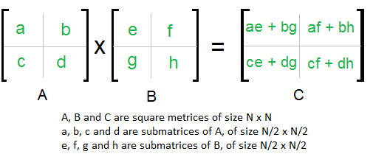
- In the above method, we do 8 multiplications for matrices of size N/2 x N/2 and 4 additions time complexity of above method is O(N³)

Strassen’s method
- The Idea is to reduce the number of recursive calls to 7.
- Strassen’s method is similar to above simple divide and conquer method
- In Strassen’s method, the four sub-matrices of result are calculated using following formulae.
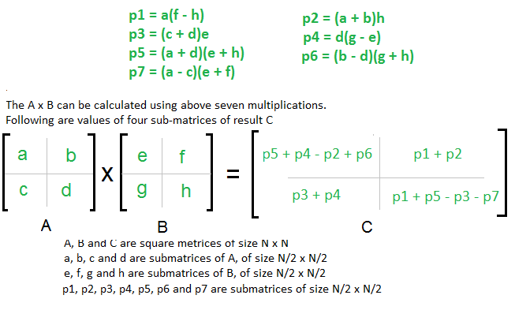
- Time complexity of above method is O(N^{Log7}) which is approximately O(N^{2.8074})
- Generally Strassen’s Method is not preferred for practical applications
Reasons
1) The constants used in Strassen’s method are high and for a typical application Naive method works better.
2) For Sparse matrices, there are better methods especially designed for them.
3) The submatrices in recursion take extra space.
4) Because of the limited precision of computer arithmetic on non-integer values, larger errors accumulate in Strassen’s algorithm than in Naive Method.


